DAY-3

1) Create a S3 Bucket and create a folder in the bucket and upload a file in the folder.

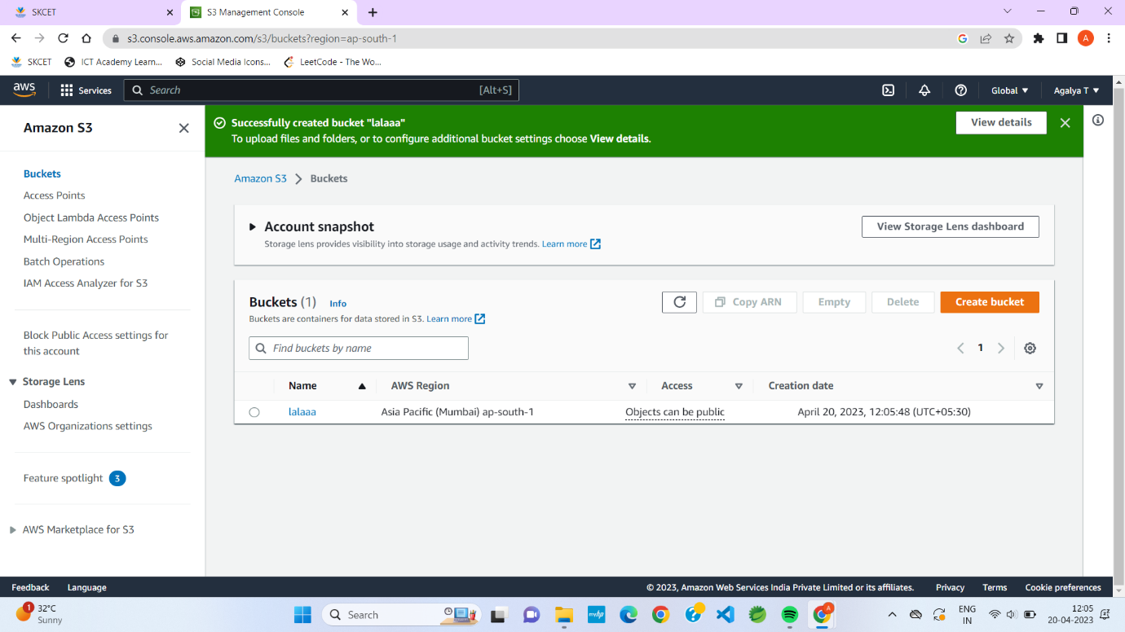

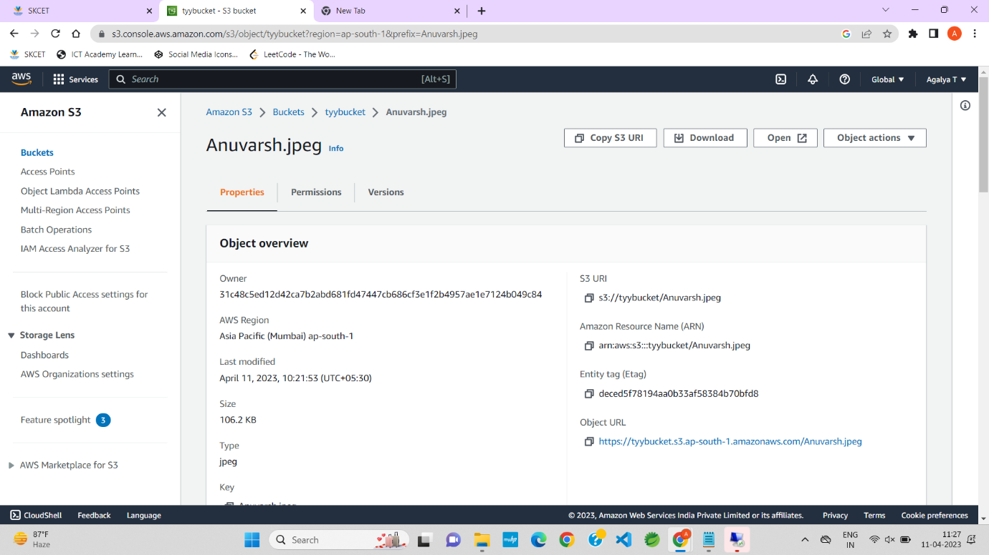

2) Disable "Block Public Access" for the bucket and enable public read access for a file.

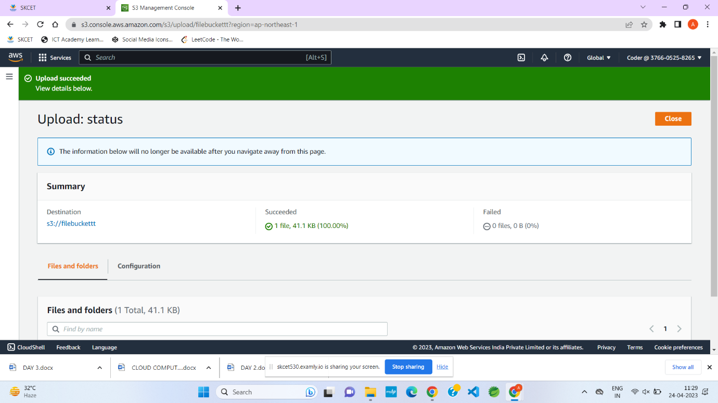

3) Create a bucket policy which should deny to read objects under a folder of a bucket.

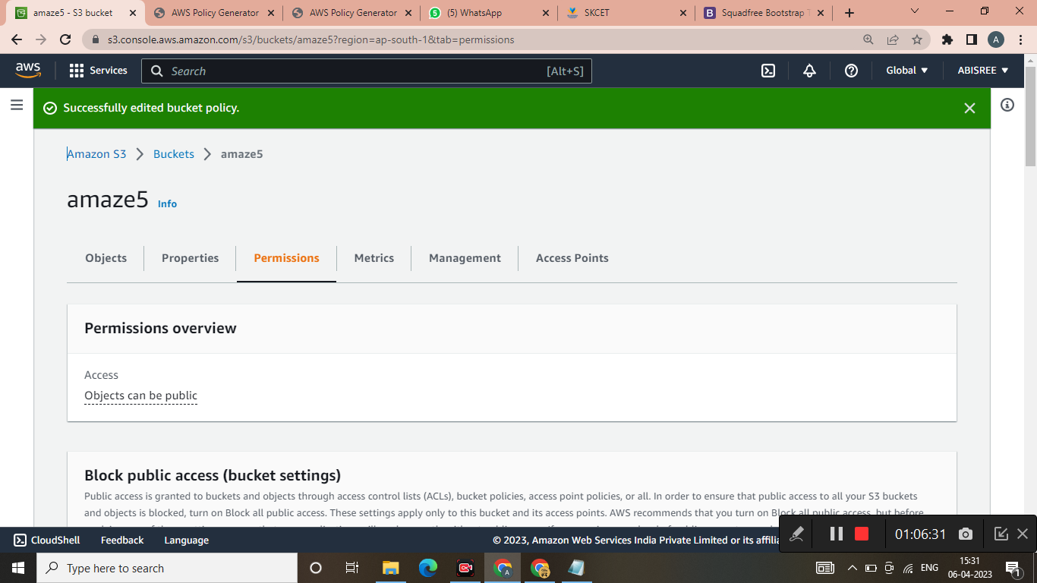

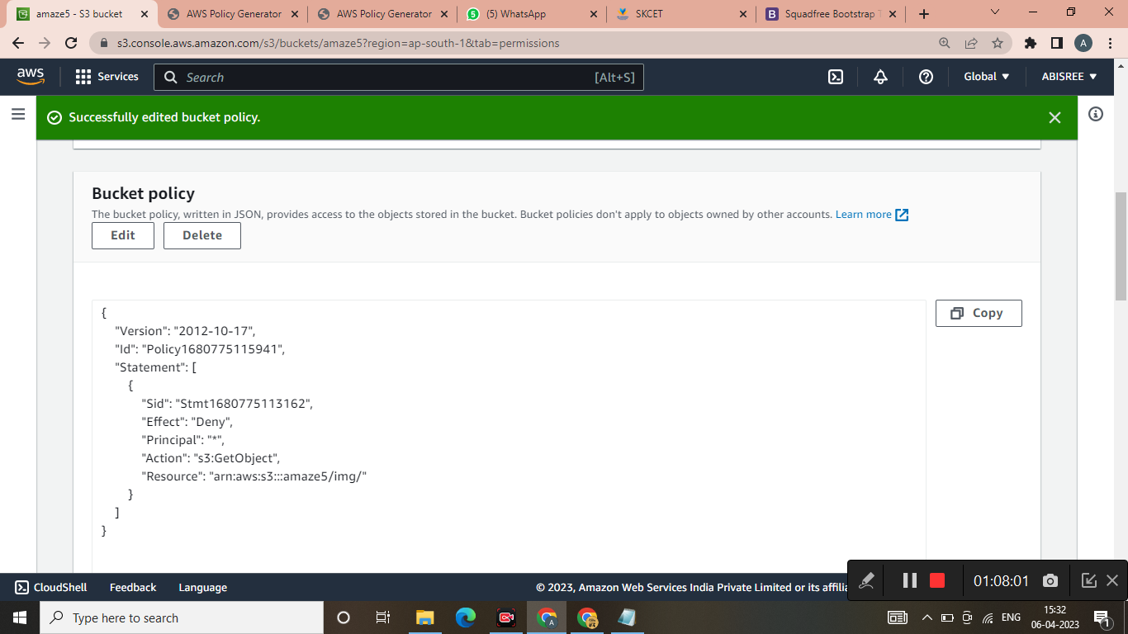

4) Enable versioning objects for a bucket and upload objects with multiple versions of it.

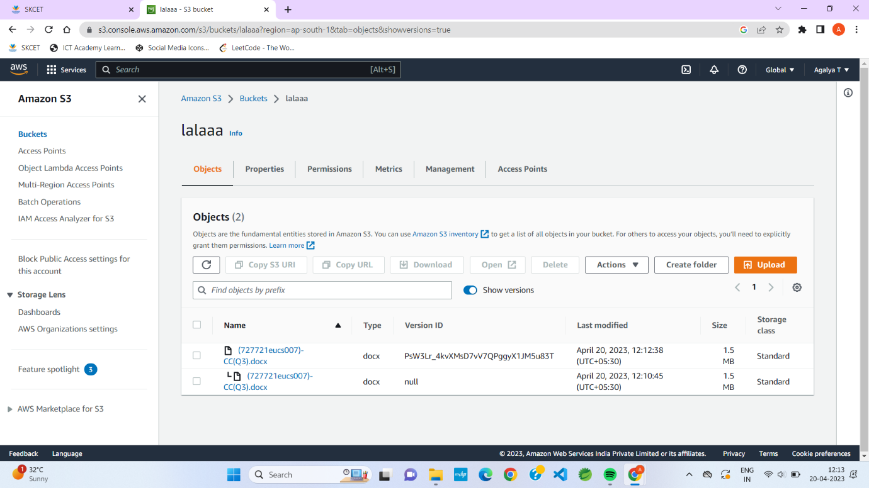

5) Host a static webpage in a bucket itself by using static website hosting feature of it.

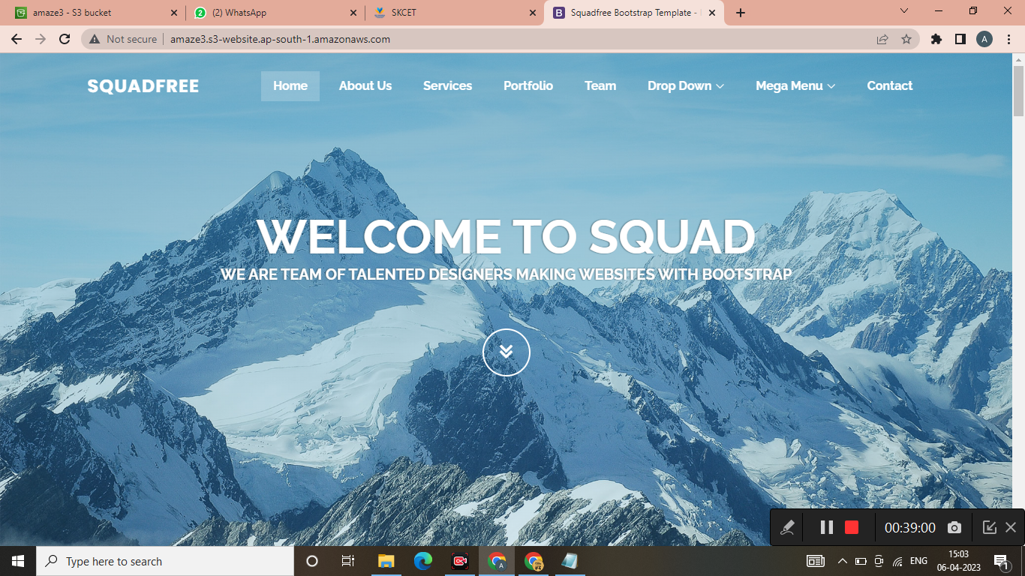

6) Enable a lifecycle management rule between various storage classes for a S3 bucket.

